Ex. No. : 6
Date:

AIM:
REG NO: 1924260033 NAME: R CHARULATHA COURSE CODE:CSA0507

SELECT with various clause – BETWEEN, IN, Aggregate function

To view the records from the tables using SELECT commands with BETWEEN, IN, Aggregate functions.

DESCRIPTION:
- The BETWEEN operator allows you to specify a range to test. We often use the BETWEEN operator in the WHERE clause of the SELECT, INSERT, UPDATE, and DELETE statements.
- The IN operator allows you to determine if a specified value matches any one of a list or a sub query.
- MySQL provides many aggregate functions that include AVG, COUNT, SUM, MIN, MAX, etc. An aggregate function ignores NULL values when it performs calculation except for the COUNT function.

BETWEEN operator:
SELECTcolumn1,column2,... FROMtable_name
WHERE expr [NOT] BETWEEN begin_expr AND end_expr;

The expr is the expression to test in the range that is defined by begin_expr and end_expr.

IN operator:
SELECTcolumn1,column2,... FROMtable_name
WHERE (expr|column_1) IN ('value1','value2',...);

Questions:
IN & BETWEEN
- List the type of the courses “Statistics” and “Programming”
- The instructor wants to know the CourseNos whose scores are in the range 50 to 80

AGGREGATE
- Find the average mark of “C002”.
- List the maximum, minimum mark for “C002”
- List the maximum, minimum, average mark for each course
- List the name of the courses and average mark of each course.
- Calculate the sum of all the scores.
- How many students are registered for each course? Display the course description and the number of students registered in each course.
- How many courses did each student register for?

OUTPUTS:
IN & BETWEEN
1)
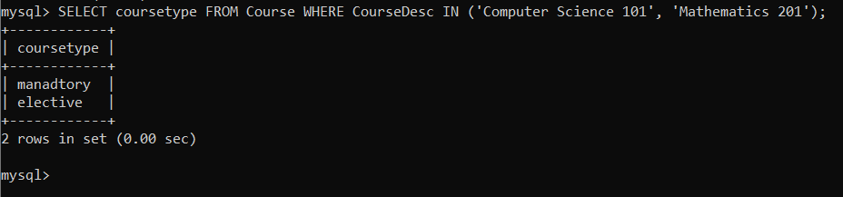
2)
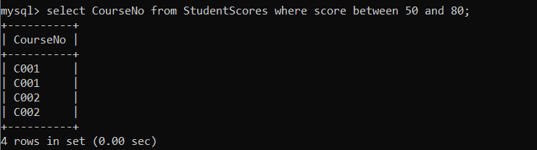

AGGREGATE
- 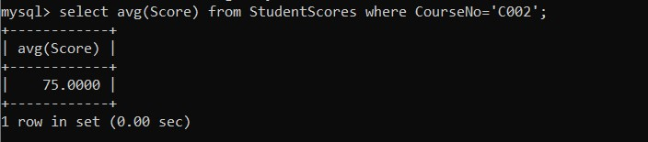

2) 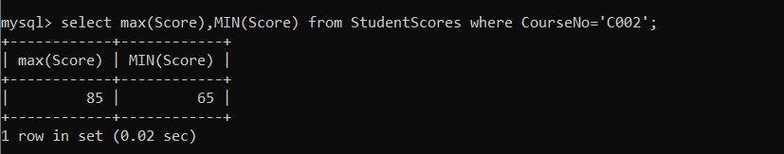

3) 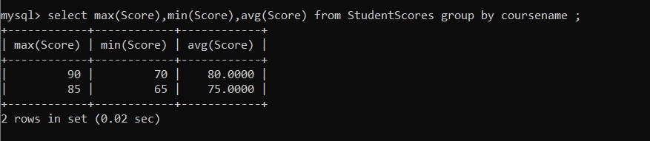

4)
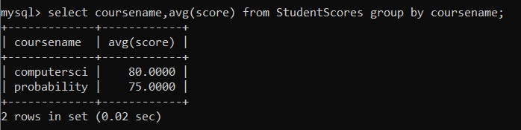
5)
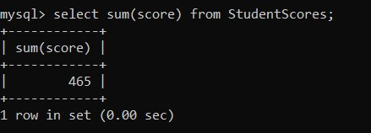

6)

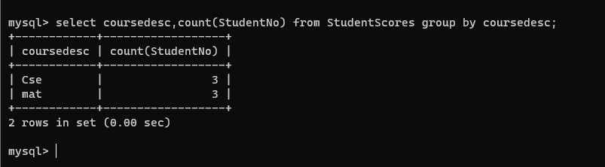

7) 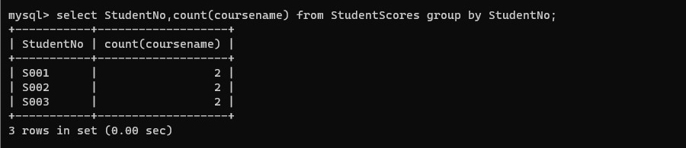
RESULT:

The records from the tables are displayed using SELECT commands with WHERE Clause and Pattern matching.

Ex. No.: 7
Date:

AIM:

SELECT with various clause – GROUP BY, HAVING, ORDER BY

To view the records from the tables using SELECT commands with Group By, Having, Order By

DESCRIPTION:
GROUP BY – HAVING:
- The GROUP BY clause groups a set of rows into a set of summary rows by values of columns or expressions. The GROUP BY clause returns one row for each group. In other words, it reduces the number of rows in the result set.
- The GROUP BY clause is used with aggregate functions such as SUM, AVG, MAX, MIN, and COUNT. The aggregate function that appears in the SELECT clause provides the information about each group.
- The GROUP BY clause is an optional clause of the SELECT statement.
- To filter the groups returned by GROUP BY clause, you use a HAVING clause.

ORDER BY:
When you use the SELECT statement to query data from a table, the result set is not sorted in any orders. To sort the result set, you use the ORDER BY clause. The ORDER BY clause allows you to:
- Sort a result set by a single column or multiple columns.
- Sort a result set by different columns in ascending or descending order.

SYNTAX:

GROUP BY – HAVING:

SELECTc1, c2,...,cn, aggregate_function(ci)
FROMtable WHEREwhere_conditions GROUP BYc1 , c2,...,cn
HAVINGconditionS

ORDER BY:

SELECT column1, column2,...
FROMtbl
ORDER BY column1 [ASC|DESC], column2 [ASC|DESC],...

ASC stands for ascending and the DESC stands for descending. By default, the ORDER BY clause sorts the result set in ascending order if you don’t specify ASC or DESC explicitly.

Questions:
GROUP BY - HAVING
- How many students are registered for each course? Display the course description and the number of students registered in each course.
- How many courses did each student register for?
ORDER BY
- Retrieve Name, Gender, Mobile No of all the students in ascending order of Reg No.
- List the faculty members in the order of older faculty first.
OUTPUTS:
1) 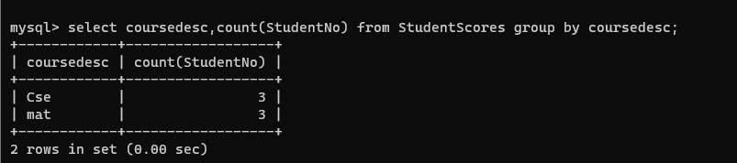
2) 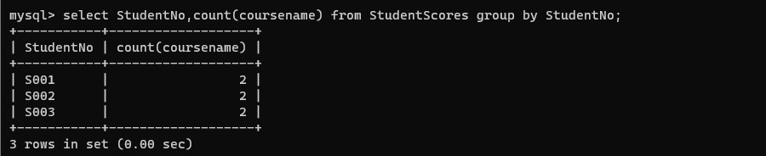
3)
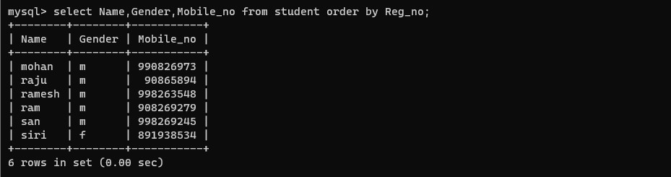
4) 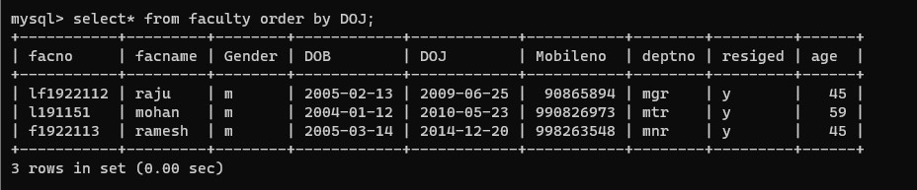

RESULT:

The records from the tables are displayed using SELECT commands with GROUP BY, HAVING and ORDER BY.

Ex. No.: 8
Date:

AIM:

Query with Sub Query& Correlated Query

To perform subquery and correlated query on the given relations.

DESCRIPTION:
SUBQUERY
A MySQL subquery is a query nested within another query such as SELECT, INSERT, UPDATE or DELETE. In addition, a MySQL subquery can be nested inside another subquery.

A MySQL subquery is called an inner query while the query that contains the subquery is called an outer query. A subquery can be used anywhere that expression is used and must be closed in parentheses.

CORRELATED QUERY:

A correlated subquery is a subquery that uses the data from the outer query. In other words, a correlated subquery depends on the outer query. A correlated subquery is evaluated once for each row in the outer query.

SYNTAX:

SUBQUERY:

SELECTc1, c2,...,cn
FROMtable
WHEREc1 IN (SELECTc1, c2,...,cn
FROMtable WHEREwhere_conditions);

CORRELATED QUERY:

SELECT*
FROMtable_name WHEREEXISTS (subquery );
Questions:

Sub-Query and Correlated Sub-Query:

- Which of the student’s score is greater than the average score?
- Which of the students’ have written more than one assessment test?
- Which faculty has joined recently and when?
- List the course and score of assessments that have the value more than the average score each Course

OUTPUTS:
- Which of the student’s score is greater than the avg score?
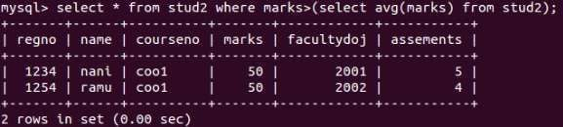
- Which of the students’ have written more than one assessment test?
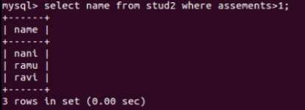
- Which faculty has joined recently and when?
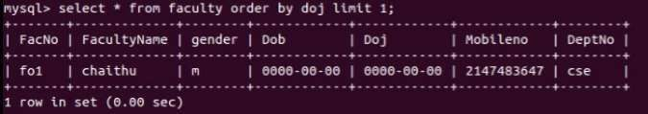

- List the course and score of assessments that have the value more than the average score each Course

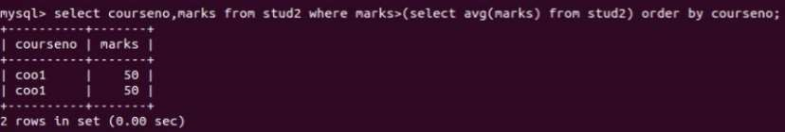

RESULT:

The records from the tables are displayed using Sub-Query and Correlated Sub-Query.

Ex.No:9

Query with Joins – EquiJoin, InnerJoin, OuterJoin

AIM: To perform JOIN using Equi Join, Inner Join, Outer Join on the given relation.

DESCRIPTION:
JOIN
A MySQL join is a method of linking data from one or more table based on values of the common column between tables.
MySQL supports the following types of joins:
- Cross join
- Inner join
- Left join
- Right join

CROSS JOIN

The CROSS JOIN makes a Cartesian product of rows from multiple tables. Suppose, you join t1 and t2 tables using the CROSS JOIN, the result set will include the combinations of rows from the t1 table with the rows in the t2 table.

INNER JOIN
To join two tables, the INNER JOIN compares each row in the first table with each row in the second table to find pairs of rows that satisfy the join-predicate. Whenever the join-predicate is satisfied by matching non-NULL values, column values for each matched pair of rows of the two tables are included in the result set.

LEFT JOIN
Unlike an INNER JOIN, a LEFT JOIN returns all rows in the left table including rows that satisfy join-predicate and rows do not. For the rows that do not match the join-predicate, NULLs appear in the columns of the right table in the result set.

RIGHT JOIN
A RIGHT JOIN is similar to the LEFT JOIN except that the treatment of tables is reversed. With a RIGHT JOIN, every row from the right table ( t2) will appear in the result set. For the rows in the right table that do not have the matching rows in the left table ( t1), NULLs appear for columns in the left table ( t1).
SYNTAX:

CROSS JOIN:
SELECTt1.id, t2.id
FROMt1CROSS JOIN t2;

INNER JOIN:
SELECTt1.id, t2.id
FROMt1INNER JOINt2 ON t1.pattern = t2.pattern;

LEFT JOIN:
SELECTt1.id, t2.id
FROMt1LEFT JOINt2 ON t1.pattern = t2.pattern
ORDER BY t1.id;

RIGHT JOIN:
SELECTt1.id, t2.id
FROMt1RIGHT JOINt2 ON t1.pattern = t2.pattern
ORDER BYt2.id;

Questions:
- List the departments where the faculty members are working.
- Find the student who has no score in any of the courses. List student name and course number.
- The office clerk needs the names of the courses taken by the faculty belonging to ‘ECE department’ whose name is ‘Kamal’

OUTPUTS:
  - List the departments where the faculty members are working.
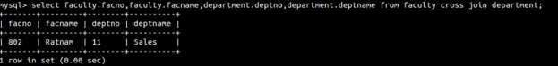

  - Find the student who has no score in any of the courses. List student name and course number.

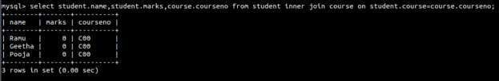

  - The office clerk needs the names of the courses taken by the faculty belonging to ‘Sales’ whose name is
‘Ratnam’

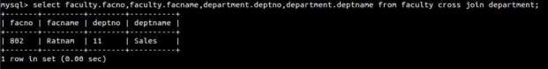

RESULT: The records from the tables are displayed using JOIN using EquiJoin, InnerJoin, OuterJoin.

